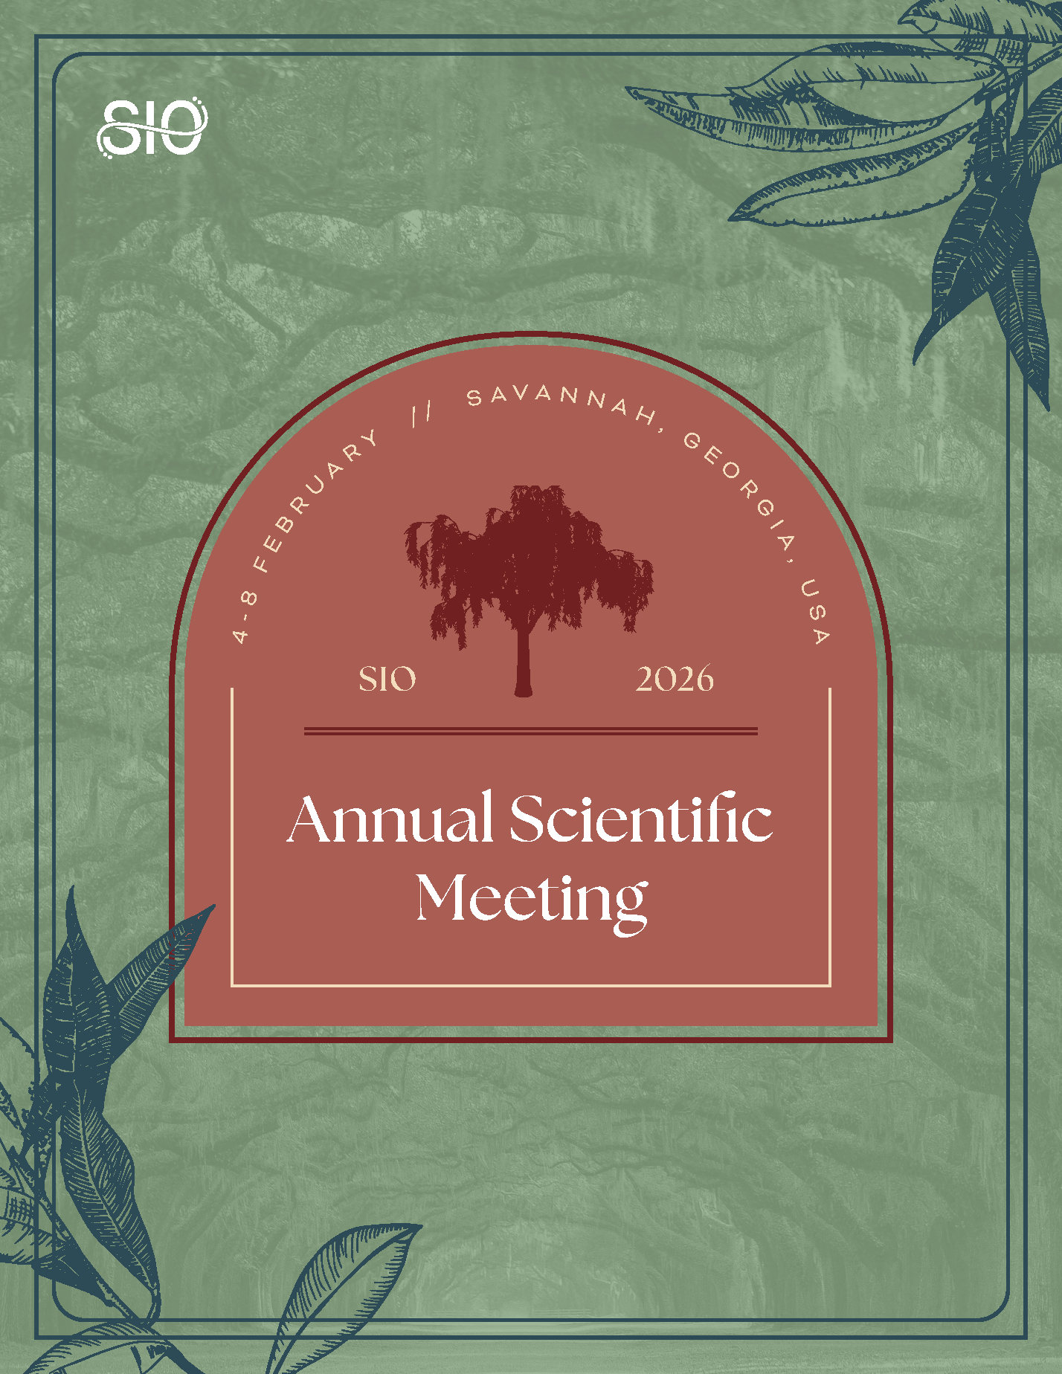
MARKETING TOOLKIT
Thank you for taking the time to exhibit at the Society of Interventional Oncology (SIO) 2026 Annual Scientific Meeting! This comprehensive marketing kit has been designed to help you spread the word and publicize your participation. Inside, you’ll find a wide range of promotional resources, templates, and graphics that are sure to generate some buzz. Happy sharing!
Let your online network know why they should join you 4 – 8 February in Savannah, Georgia, by utilizing the provided:
- Talking Points
- Pass-Along Email Template
- Social Media Messaging
- Shareable Graphics and Photos
Questions?
Visit the SIO website or reach out to us at info@sio-central.org.

TALKING POINTS
What is the SIO Annual Scientific Meeting?
The SIO Annual Scientific Meeting is the premier event for interventional oncology (IO) professionals. Since its inception, it has provided comprehensive learning sessions, opportunities for face-to-face networking, and skill-building activities for practitioners across the globe. The 2026 event — taking place 4 - 8 February in Savannah, Georgia — is expected to deliver just that and more.
Why Attend?
Learn About the Latest in IO
Whether you’re a student, mid-career professional, or IO expert, the SIO 2026 Annual Scientific Meeting provides education for individuals at every career level. This year’s program boasts an impressive lineup of hands-on workshops, learning sessions, and expert-led lectures. View the full online schedule here.
Advance Your Expertise
New at the SIO 2026 Annual Scientific Meeting, the inaugural Palliative Pain in Cancer Patients Master Class delivers a comprehensive, case-driven experience designed to elevate the interventional oncologist’s approach to cancer-related pain. SIO is also proud to host The RISE Forum, a comprehensive, expert-led program designed to equip interventional oncologists, scientists, and clinical investigators with the tools and knowledge to advance impactful research across the translational spectrum. From foundational laboratory platforms to clinical trial design and next-generation innovations, this immersive course spans the critical elements necessary for driving discovery and accelerating clinical progress in interventional oncology.

Experience IO Essentials Programming
The IO Essentials Program — taking place Wednesday, 4 February – Saturday, 7 February 2026 — was designed by leading experts in IO to provide early-career attendees with an opportunity to participate in hands-on learning, dive into cutting-edge research, and collect tips on how to build a successful clinical practice.

Create New Connections
The SIO Annual Scientific Meeting cultivates a collaborative environment, attracting leading industry partners, medical students, residents, researchers, scientists, physicians, health specialists, and other medical professionals from across the globe. During the five-day event, you are encouraged to exchange ideas, share best practices, and identify growth opportunities through our face-to-face networking functions.
Score Significant Savings
Join the SIO community to secure the best available rate on this can't-miss event. By becoming a member, you will receive discounted registration to all SIO events — like the Annual Scientific Meeting — inclusion in the member directory, exclusive educational opportunities, and countless other year-round benefits. Bundle your registration with an SIO membership today!
Stay Close to Action
SIO has reserved a block of discounted rooms for the SIO 2026 Annual Scientific Meeting at The Westin Savannah Harbor Golf Resort & Spa and at The Marriott Savannah Riverfront, near the Savannah Convention Center. The discount rate is $275 per night, plus taxes and fees. The cut-off date to book your room is Monday, 5 January 2026, or until rooms are sold out — whichever occurs first.

PASS ALONG EMAIL
Subject: Join Me at the SIO 2026 Annual Scientific Meeting
Hi [insert name of recipient],
The SIO Annual Scientific Meeting is taking place 4 - 8 February in Savannah, Georgia, and I’d love for you to join me. This can’t-miss event is led by the best and brightest in the field of interventional oncology (IO), providing unparalleled opportunities to acquire knowledge, create connections, and elevate your professional skill set.
With workshops covering innovative topics pertinent to our specialty, you will leave feeling empowered to bring new techniques and practices back to your workplace. This year, I am particularly looking forward to [insert name of scheduled event].
If you would like to learn more or register, please visit the SIO website.
I hope to see you there!

[insert your name and signature]

SOCIAL MEDIA MESSAGING
Leverage social media to promote your participation at the SIO 2026 Annual Scientific Meeting. Feel free to copy/paste the posts below, or make a message of your own, to keep your online network in the know.
Don’t forget to follow our channels to stay up to date on all things leading up to #SIOSavannah!
- Facebook: @SIOcentral
- LinkedIn: Society of Interventional Oncology
- X: @SIO_Central
X Posts
- I’m going to #SIOSavannah, the premier education and networking event for #IO professionals! Secure your spot by 1 January 2026 to score significant savings: https://www.sio-central.org/Events/Annual-Scientific-Meeting/Registration
- Join me 4 – 8 February at #SIOSavannah to learn about cutting-edge #IO therapies! Take a look at the robust programming being offered and start mapping out your experience today: https://www.sio-central.org/Events/Annual-Scientific-Meeting/2025-Program
- Year after year, the SIO Annual Scientific Meeting has served as the perfect place to pick up innovative ideas, create connections, and develop skills that have helped elevate my career. See for yourself by joining me this winter in Savannah, Georgia: https://www.sio-central.org/Events/Annual-Scientific-Meeting
- I can’t wait for the chance to network and learn from #IO experts at #SIOSavannah, 4 – 8 February. Hope to see you there! https://www.sio-central.org/Events/Annual-Scientific-Meeting

Facebook/LinkedIn Posts
- Join me in learning about the latest and greatest in interventional oncology (#IO) at the SIO 2026 Annual Scientific Meeting, taking place 4 - 8 February 2026 in Savannah, Georgia. Visit the SIO website to register and start mapping out your educational experience today: https://www.sio-central.org/Events/Annual-Scientific-Meeting/Registration
- The SIO 2026 Annual Scientific Meeting is taking place 4 - 8 February 2026 in Savannah, Georgia! I can’t wait to connect with other healthcare professionals while expanding my knowledge of interventional oncology (#IO). Don’t miss out — secure your spot today: https://www.sio-central.org/Events/Annual-Scientific-Meeting/Registration
- Whether you are an interventional oncology (#IO) expert, new to the field, or somewhere in between, the SIO 2026 Annual Scientific Meeting has something for you! Visit the following link to learn all about #SIOSavannah and the robust programming being offered: https://www.sio-central.org/Events/Annual-Scientific-Meeting
- This winter, the SIO 2026 Annual Scientific Meeting will reunite hundreds of intervention oncology (#IO) professionals for five days of quality programming. While this event offers countless highly anticipated attractions, I am most excited to elevate my knowledge and skills through [insert name of scheduled event]. Check out the full schedule of events to discover what other opportunities are in store: https://www.sio-central.org/Events/Annual-Scientific-Meeting/2026-Program

SHAREABLE GRAPHICS
Catch the eyes of your connections by including a branded visual in your next #SIOSavannah email or social media post. Click here to download the full suite of graphics.
TIPS AND TRICKS FOR SOCIAL MEDIA SUCCESS:
- In addition to posting on your personal social media accounts, consider promoting the event in a related group you belong to — just be sure to abide by group policy.
- Customization can go a long way! Pair your post with a personal message, graphic, or picture from a past event to help drive engagement.
- Don’t forget to tag SIO and use the #SIOSavannah to boost visibility.

Flaunt Your Photos
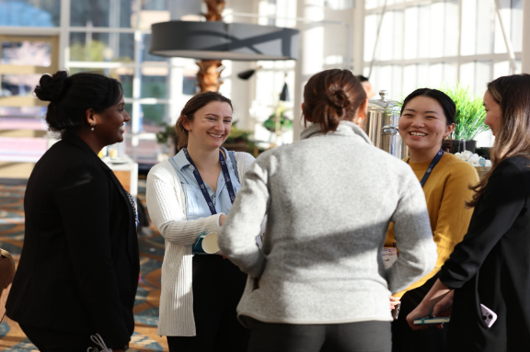
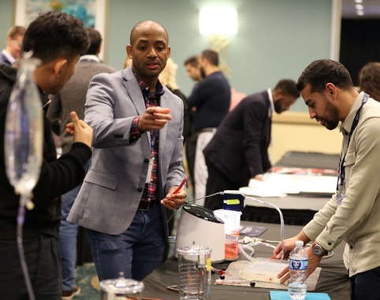
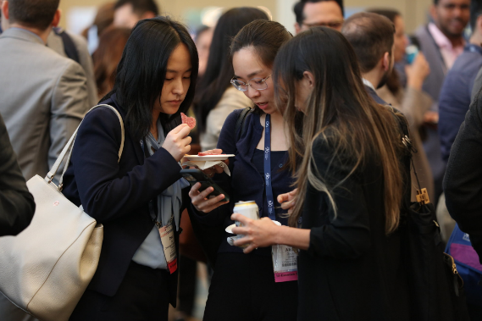
Are you a returning participant? Show off your on-site photos from past events to convey to your network just how empowering the SIO Annual Scientific Meeting can be. While you are at it, flip through the photos featured in our digital gallery to see if you can spot any familiar faces from the annual meetings of yesteryear.

